**User documentation**

The homepage is login page if u want to create account click sign up

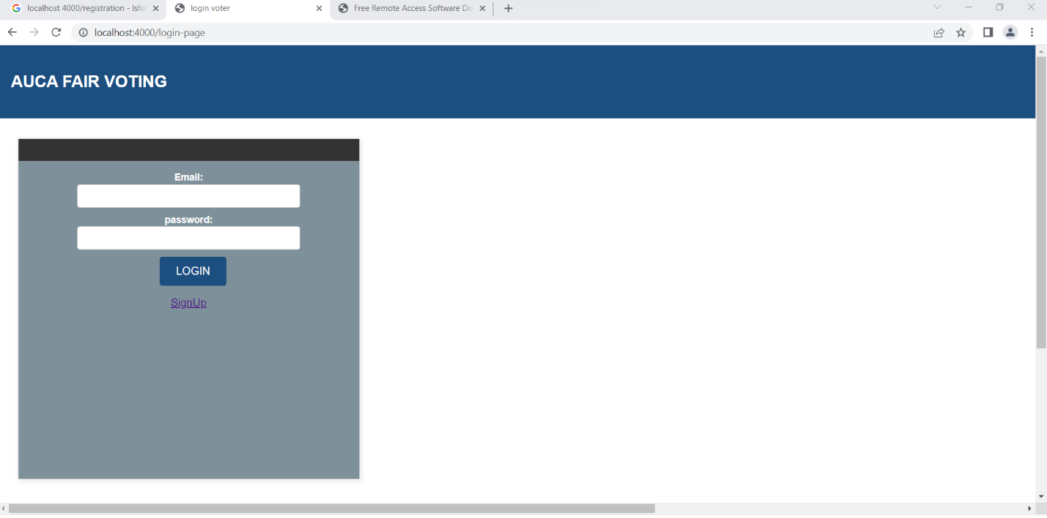

When u click sign up it will take u to the sign up page

**To**

**to**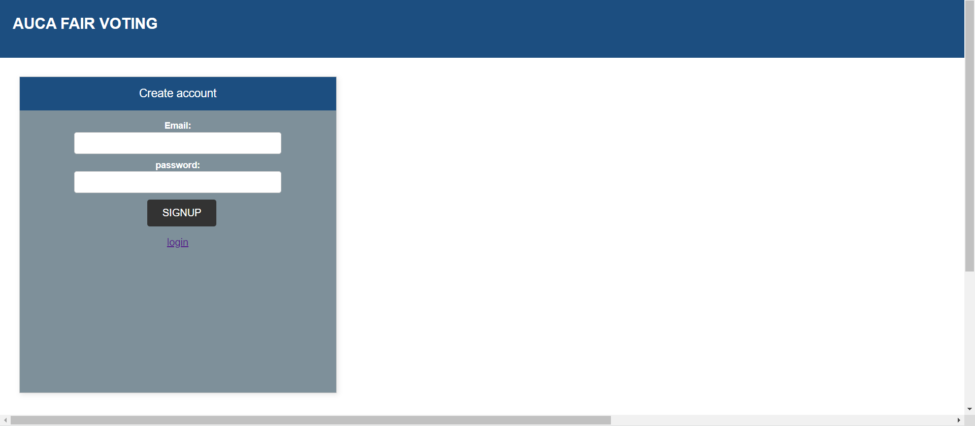

to login as the admin your email should [contain@auca.com](mailto:contain@auca.com) and password should [contain@.but](mailto:contain@.but) for the user you just have to enter normal email and passwords.

After logging in as the user with your credentials you go to the home page

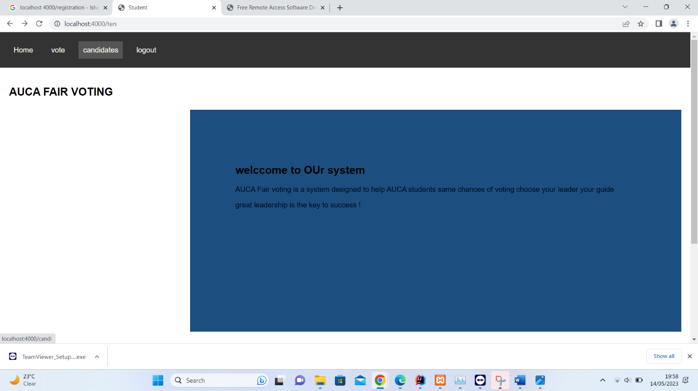

After going to home page if you want to vote for click on candidates it will take you to the candidate page

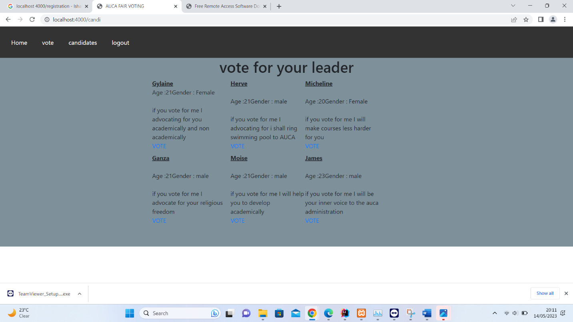

If you want to vote click on vote button

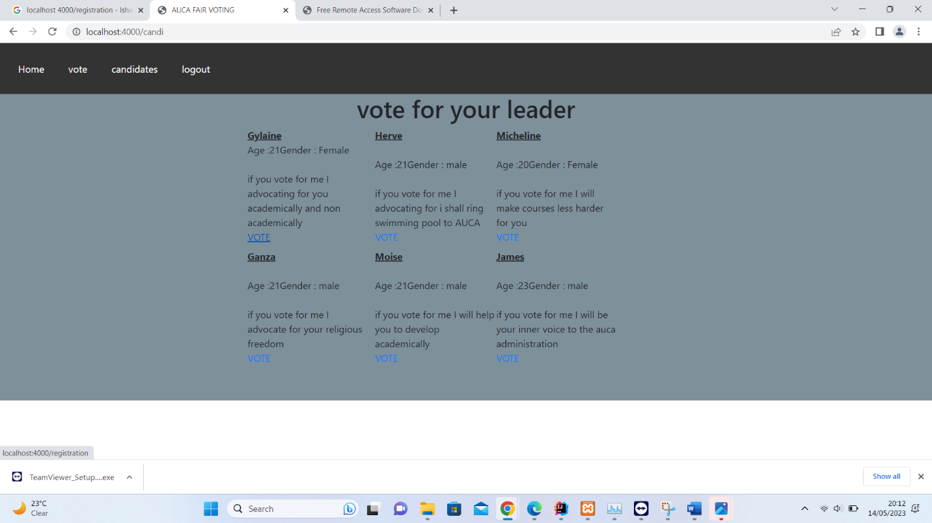

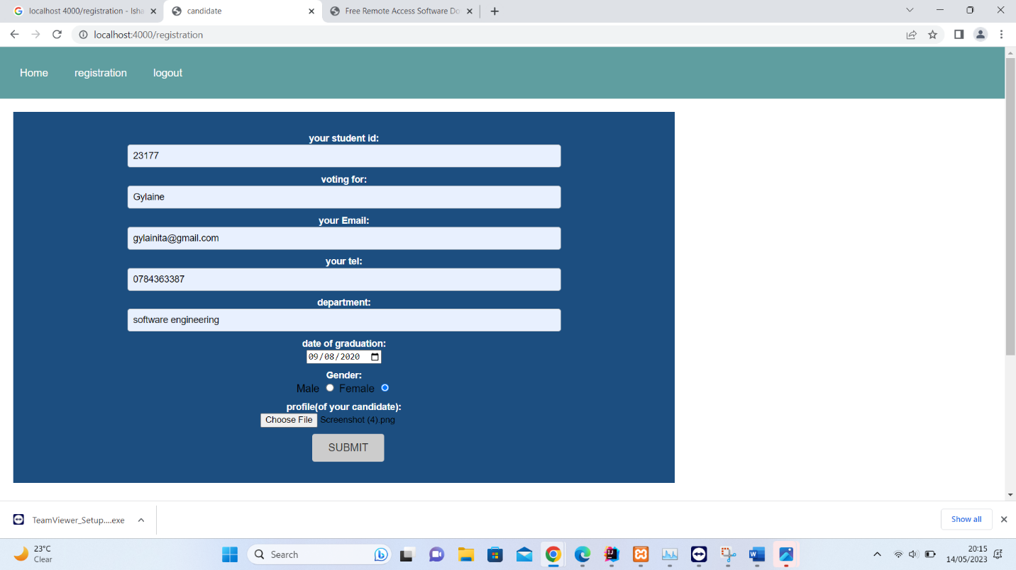

After clicking the vote button then you go the registration page you enter your student id who you are voting for ,your email ,department and graduation date and upload the picture of your candidate after click submit button you will get a message that your vote was registered 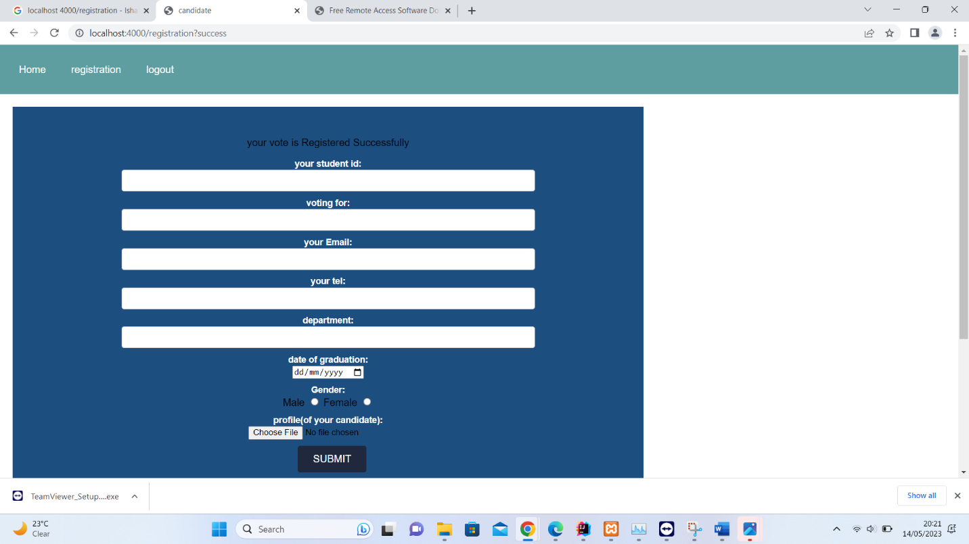

Is the part of the user so now let us go to the admin part who has all permission to update ,delete , register and to search

To login as the admin

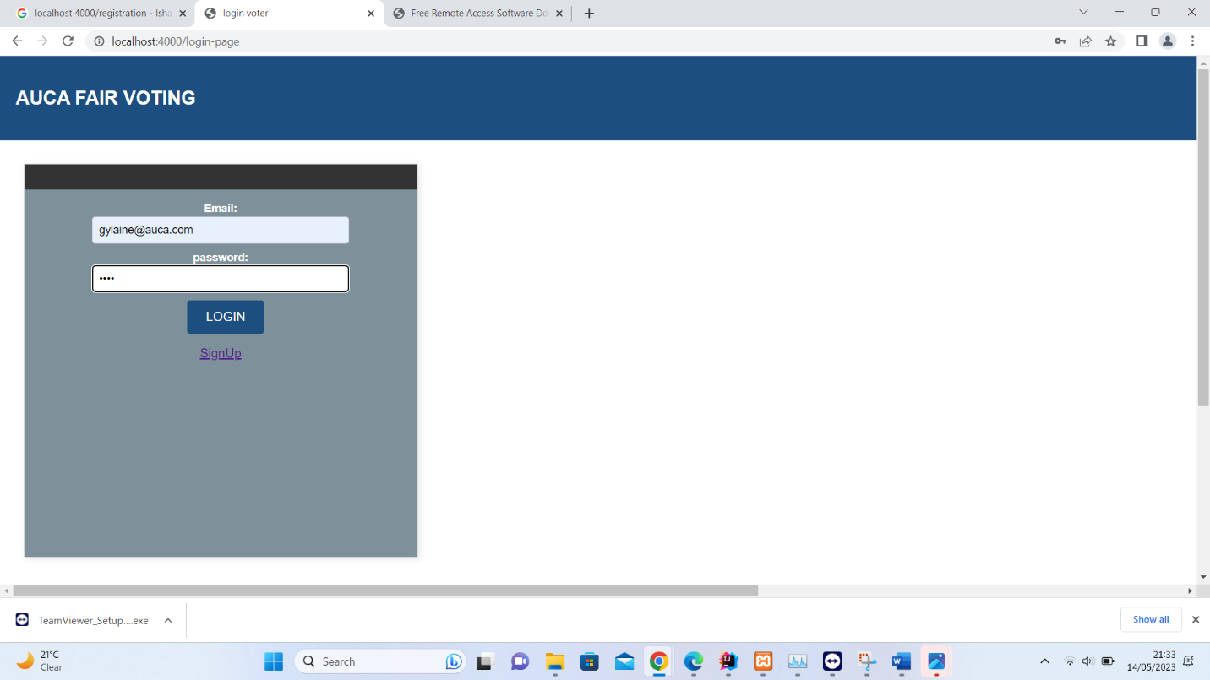\

After login the admin can access all the pages

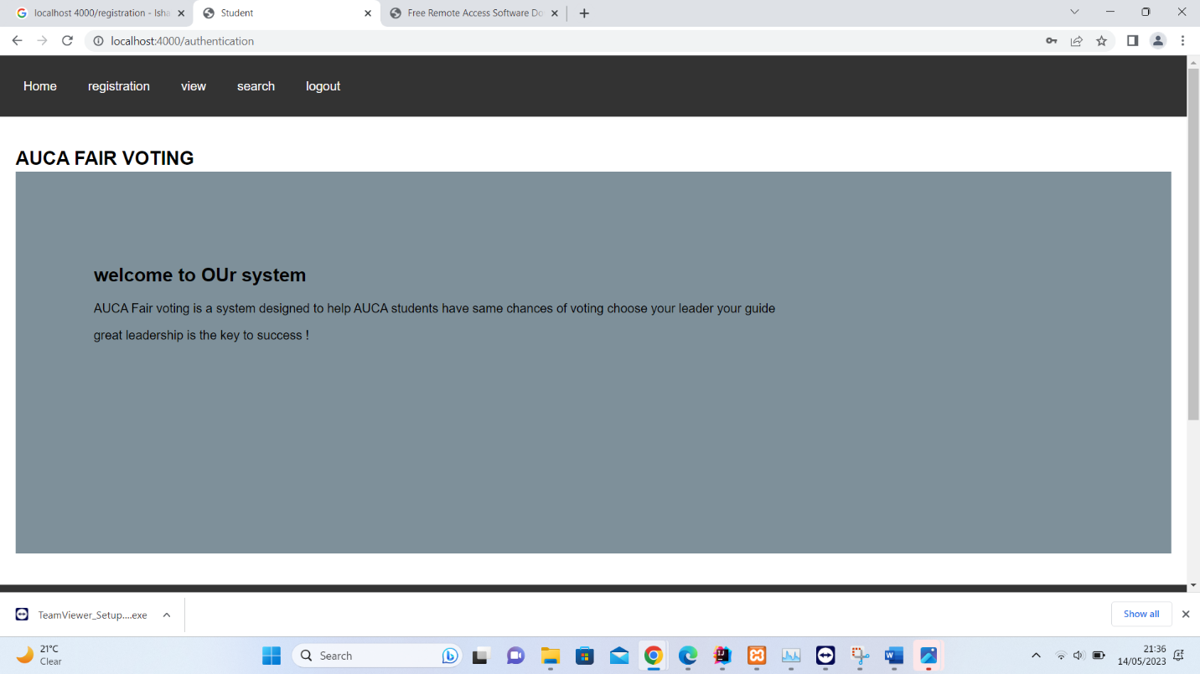

For registration the admin can click on the registration link above.

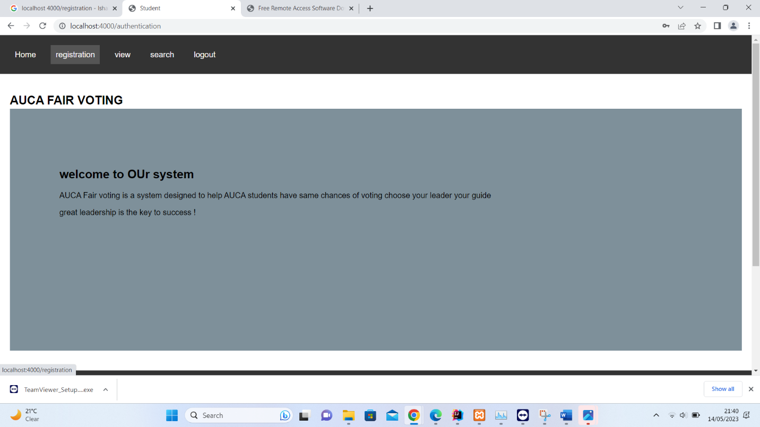

After clicking registartion it will take you to registration page

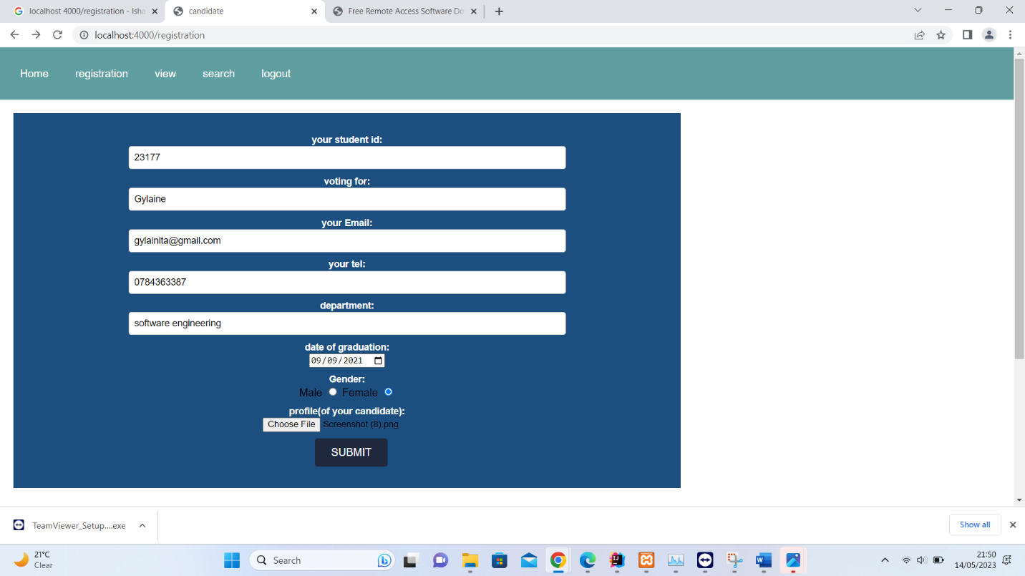

after clicking submit button it will take give you a message



Incase you want to view files click on view

If you want to delete click delete you will receive a message to confirm if you really want to delete

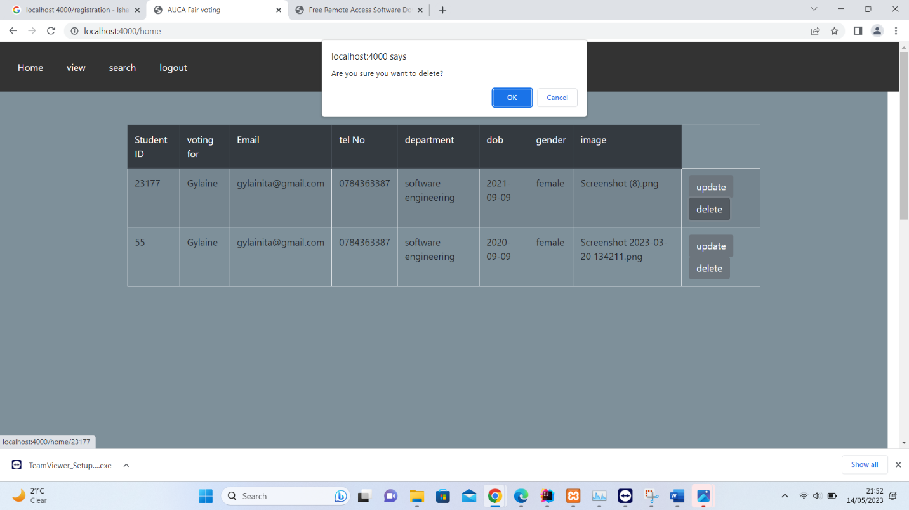

Click ok if you want to delete click ok if it is a mistake click cancel your data will remain.

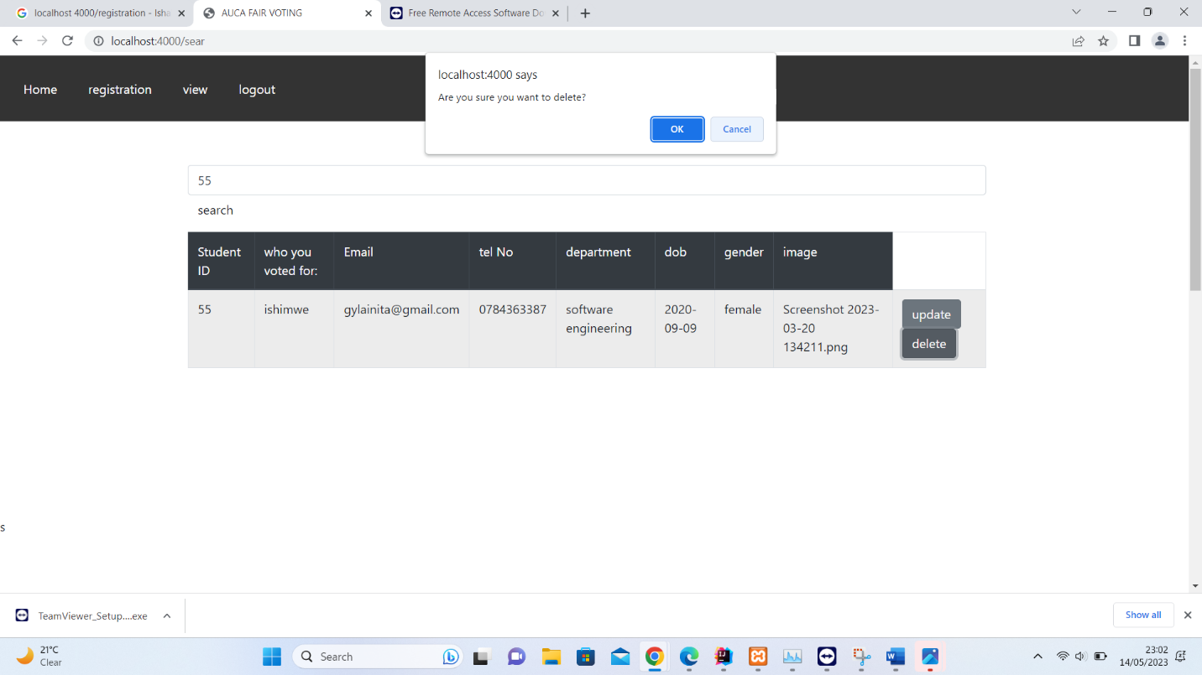

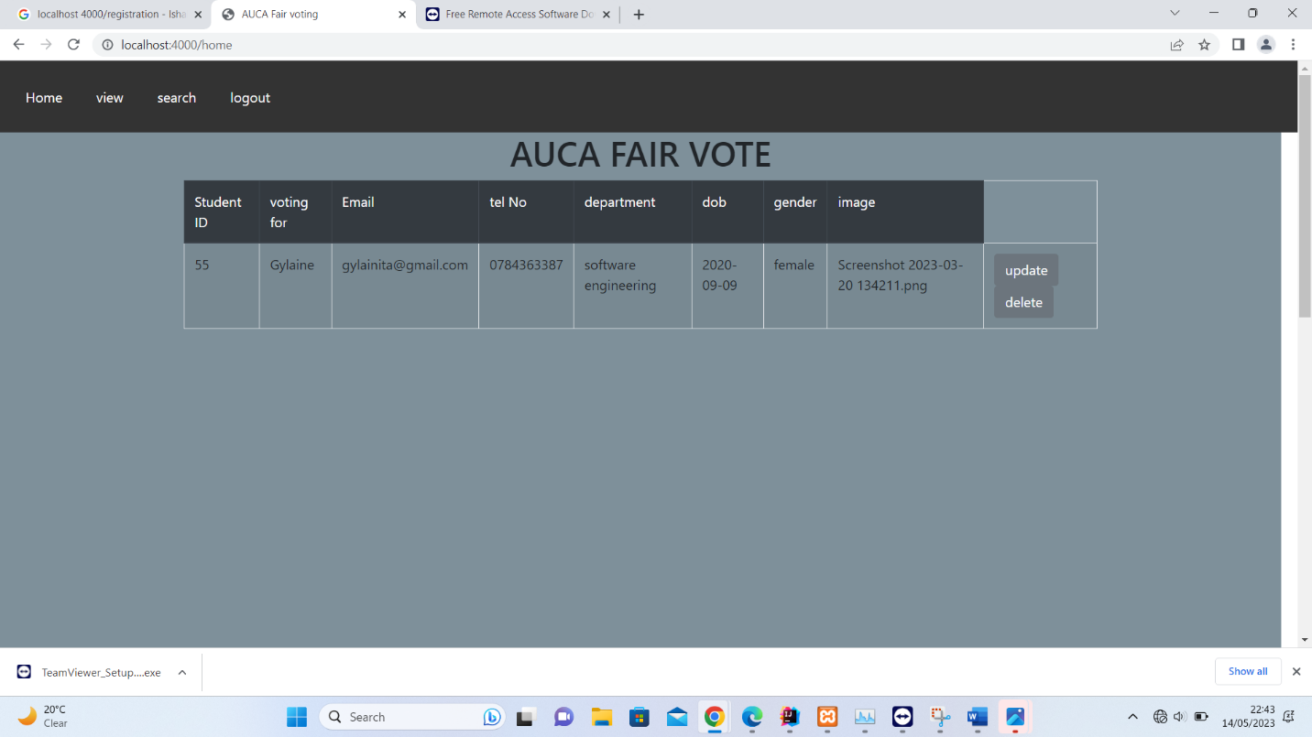

Then your data will be deleted

Updating

Click on update

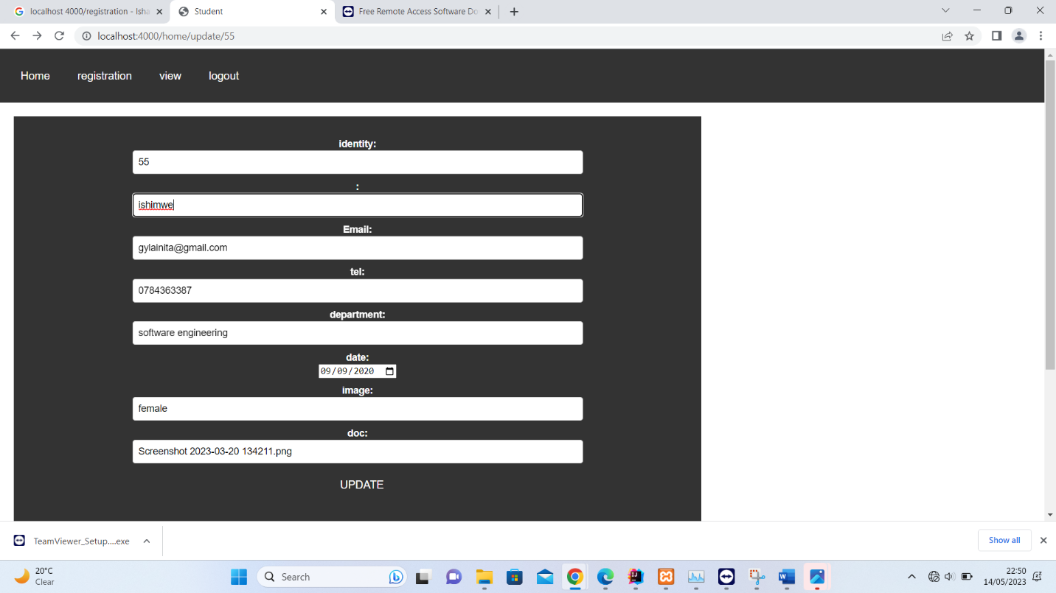

After updating it will take you to the view

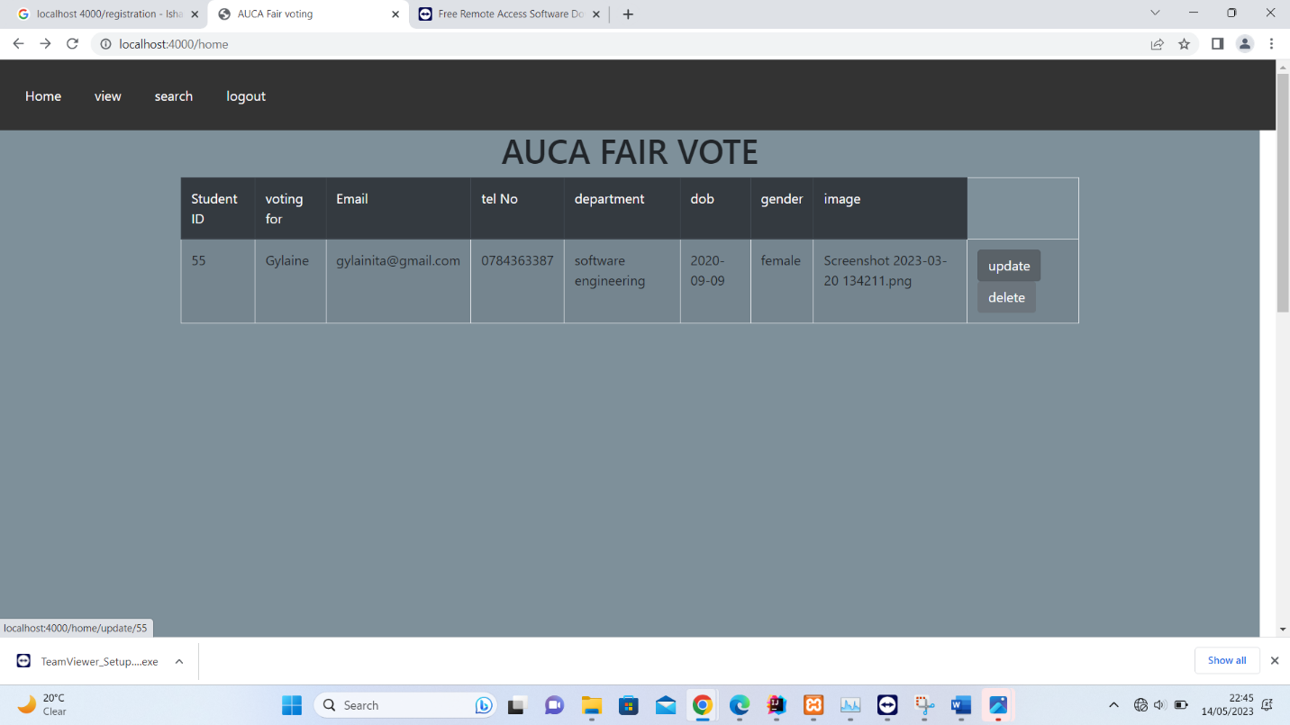

To search for who voted you search by id

